LAB EXPIREMENTS
4.DML Commands with Constraints –UPDATE, DELETE :
AIM:
To perform Data Manipulation Language (DML) commands such as UPDATE and DELETE on the employee table.
PROCEDURE:
- Select the company database.
- Create the employee table.
- Insert employee records into the table.
- Update the required employee details using the UPDATE command.
- Display the updated table using SELECT.
- Delete the required employee records using the DELETE command.
- Display the remaining records using SELECT.
- Verify the changes.

PROGRAM:
PROGRAM:
Step 1: Select Database
USE company;

Step 2: Create Employee Table
CREATE TABLE employee
(
Worker_ID INT PRIMARY KEY,
Name VARCHAR(50),
Department VARCHAR(30),
Salary INT,
Phone BIGINT,
Department_Manager VARCHAR(30)
);

Step 3: Insert Records
INSERT INTO employee VALUES
(1101,'Yuvan','IT',20000,8838997561,'Shankar'),
(1102,'Fahadi','HR',100000,9996666,'Ravi'),
(1301,'Fahim','IT',120000,1234578,'Ravi'),
(1405,'Santhosh','Software Developer',150000,1987654,'Ravi'),
(1501,'Shankar','HR',20000,6584231,'Shankar'),
(1705,'Dharun','Software Developer',100000,75816452,'Abban'),
(1835,'Akash','IT',120000,8561457,'Udhay'),
(1295,'Udhay','HR',120000,657564823,'Rithesh'),
(1125,'Dhanush','Software Engineering',100000,1372941,'Udhay'),
(1055,'Harifaran','IT',5000,9814521,'Ravi');

Question 1: Update the employee name whose Worker_ID is 1101
UPDATE employee
SET Name = 'Yuvan Shankar'
WHERE Worker_ID = 1101;
Display Output
SELECT * FROM employee;

Question 2: Delete the employee who resigned (Worker_ID = 1705)
DELETE FROM employee
WHERE Worker_ID = 1705;
Display Output
SELECT * FROM employee;

Question 3: Modify the salary of employee 'Fahim' to 130000
UPDATE employee
SET Salary = 130000
WHERE Name = 'Fahim';
Display Output
SELECT * FROM employee;

Question 4: Remove all employees whose salary is greater than 120000
DELETE FROM employee
WHERE Salary > 120000;
Display Output
SELECT * FROM employee;
OUTPUT:

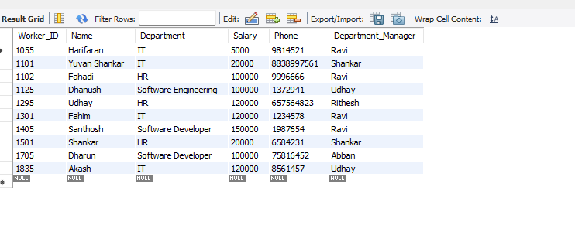
RESULT:
Thus, the DELETE command was executed successfully, and the required employee record was deleted from the employee table.

EXPIREMENT:5

SELECT with various clause – WHERE, pattern matching
AIM:
To view records from the employee table using the SELECT statement with WHERE clause and LIKE operator.

PROCEDURE:
- Select the company database.
- Create the employee table.
- Insert records into the employee table.
- Execute the SELECT statement using the WHERE clause.
- Execute the SELECT statement using the LIKE operator.
- Display the output for each query.
- Verify the results.

Step 1: Select Database
USE company;

Step 2: Create Employee Table
CREATE TABLE employee
(
Worker_ID INT PRIMARY KEY,
Name VARCHAR(50),
Department VARCHAR(30),
Salary INT,
Phone BIGINT,
Department_Manager VARCHAR(30)
);

Step 3: Insert Records
INSERT INTO employee VALUES
(1101,'Yuvan','IT',20000,8838997561,'Shankar'),
(1102,'Fahadi','HR',100000,9996666,'Ravi'),
(1301,'Fahim','IT',120000,1234578,'Ravi'),
(1405,'Santhosh','Software Developer',150000,1987654,'Ravi'),
(1501,'Shankar','HR',20000,6584231,'Shankar'),
(1705,'Dharun','Software Developer',100000,75816452,'Abban'),
(1835,'Akash','IT',120000,8561457,'Udhay'),
(1295,'Udhay','HR',120000,657564823,'Rithesh'),
(1125,'Dhanush','Software Engineering',100000,1372941,'Udhay'),
(1055,'Harifaran','IT',5000,9814521,'Ravi');
WHERE Clause
Question 1: Display Worker_ID, Name and Phone of all employees
SELECT Worker_ID, Name, Phone
FROM employee;

Question 2: Display all employees working in the IT department
SELECT *
FROM employee
WHERE Department='IT';

Question 3: Display employees whose salary is greater than 100000
SELECT *
FROM employee
WHERE Salary > 100000;

Question 4: Display employees managed by 'Ravi'
SELECT *
FROM employee
WHERE Department_Manager='Ravi';

Question 5: Display employees whose salary is less than 50000
SELECT *
FROM employee
WHERE Salary < 50000;

LIKE Operator
Question 6: Display employees whose names end with 'sh'
SELECT *
FROM employee
WHERE Name LIKE '%sh';

Question 7: Display employees whose names contain 'sh'
SELECT *
FROM employee
WHERE Name LIKE '%sh%';

Question 8: Display employees whose department contains 'Soft'
SELECT *
FROM employee
WHERE Department LIKE '%Soft%';

Question 9: Display employees whose names do not contain six letters
SELECT *
FROM employee
WHERE Name NOT LIKE '______';

Question 10: Display employees whose names contain 'an'
SELECT *
FROM employee
WHERE Name LIKE '%an%';

OUTPUT:
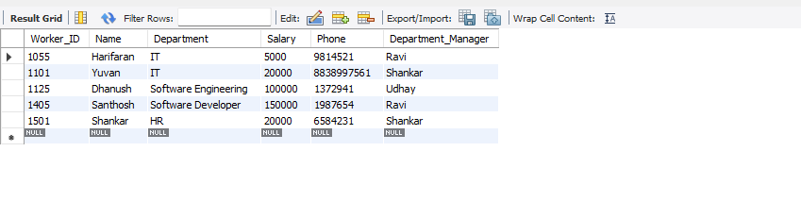

RESULT:
Thus, the SELECT statement with WHERE clause and LIKE operator was executed successfully on the employee table in the company database, and the required records were retrieved successfully.

EXPIREMENT 6:
SELECT with various clause – BETWEEN, IN, Aggregate function
AIM:
To view the records from the employee table using the SELECT statement with BETWEEN, IN, and Aggregate Functions.
PROCEDURE:
Create the company database.
- Select the company database using the USE command.
- Create the employee table with the required columns.
- Insert employee records into the table using the INSERT statement.
- Display all employee records using the SELECT statement.
- Retrieve employee details using the IN operator.
- Retrieve employee details using the BETWEEN operator.
- Calculate the average salary using the AVG() function.
- Find the maximum and minimum salary using the MAX() and MIN() functions.
- Display the maximum, minimum, and average salary department-wise using the GROUP BY clause.
- Display the average salary for each department.
- Calculate the total salary of all employees using the SUM() function.
- Count the number of employees in each department using the COUNT() function.
- Count the number of employees under each department manager using the GROUP BY clause.
Verify the output obtained for all the queries.
PROGRAM:
Step 1: Create the company database.
CREATE DATABASE company;
Step 2: Select the company database.
USE company;
Step 3: Create the employee table.
CREATE TABLE employee
(
Worker_ID INT PRIMARY KEY,
Name VARCHAR(50),
Department VARCHAR(30),
Salary INT,
Phone BIGINT,
Department_Manager VARCHAR(30)
);
Step 4: Insert records into the employee table.
INSERT INTO employee VALUES
(1101,'Yuvan','IT',20000,8838997561,'Shankar'),
(1102,'Fahadi','HR',100000,9996666,'Ravi'),
(1301,'Fahim','IT',120000,1234578,'Ravi'),
(1405,'Santhosh','Software Developer',150000,1987654,'Ravi'),
(1501,'Shankar','HR',20000,6584231,'Shankar'),
(1705,'Dharun','Software Developer',100000,75816452,'Abban'),
(1835,'Akash','IT',120000,8561457,'Udhay'),
(1295,'Udhay','HR',120000,657564823,'Rithesh'),
(1125,'Dhanush','Software Engineering',100000,1372941,'Udhay'),
(1055,'Harifaran','IT',5000,9814521,'Ravi');
Step 5: Display all employee records.
SELECT * FROM employee;
Step 6: Display employees working in IT and HR departments using the IN operator.
SELECT *
FROM employee
WHERE Department IN ('IT','HR');
Step 7: Display employees whose salary is between 50000 and 120000 using the BETWEEN operator.
SELECT *
FROM employee
WHERE Salary BETWEEN 50000 AND 120000;
Step 8: Find the average salary of all employees.
SELECT AVG(Salary) AS Average_Salary
FROM employee;
Step 9: Find the maximum and minimum salary.
SELECT MAX(Salary) AS Maximum_Salary,
MIN(Salary) AS Minimum_Salary
FROM employee;
Step 10: Display the maximum, minimum, and average salary for each department.
SELECT Department,
MAX(Salary) AS Maximum_Salary,
MIN(Salary) AS Minimum_Salary,
AVG(Salary) AS Average_Salary
FROM employee
GROUP BY Department;
Step 11: Display the average salary of each department.
SELECT Department,
AVG(Salary) AS Average_Salary
FROM employee
GROUP BY Department;
Step 12: Calculate the total salary of all employees.
SELECT SUM(Salary) AS Total_Salary
FROM employee;
Step 13: Count the number of employees in each department.
SELECT Department,
COUNT(*) AS Number_of_Employees
FROM employee
GROUP BY Department;
Step 14: Count the number of employees under each department manager.
SELECT Department_Manager,
COUNT(*) AS Number_of_Employees
FROM employee
GROUP BY Department_Manager;
OUTPUT:
1.IN OPERATOR:
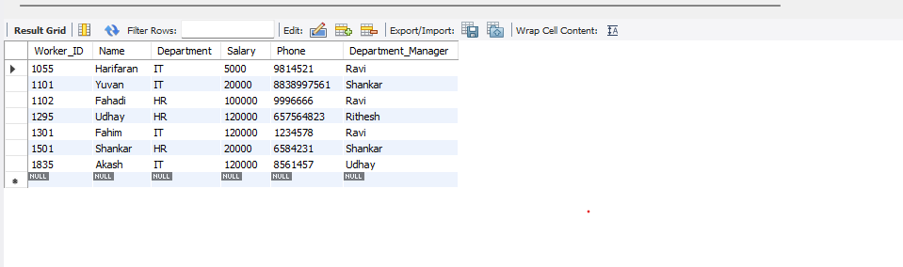
2.BETWEEN OPERATOR:
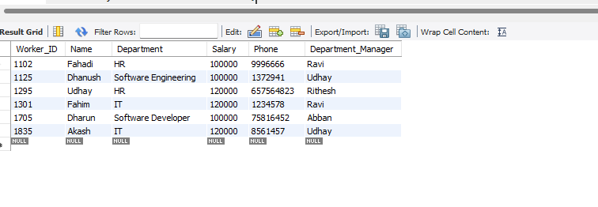
3.AGGREGATE:
AVERAGE SALARY:
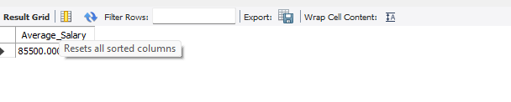
RESULT:
Thus, the BETWEEN operator, IN operator, and Aggregate Functions (AVG, SUM, MIN, MAX, and COUNT) were executed successfully on the employee table, and the desired output was obtained.

EXPIREMENT :7
SELECT with various clause – GROUP BY, HAVING, ORDER BY .
AIM:
To view the records from the employee table using GROUP BY, HAVING, and ORDER BY clauses.
PROCEDURE:
Create the company database.
- Select the company database using the USE command.
- Create the employee table.
- Insert employee records into the table.
- Display all employee records using the SELECT statement.
- Group employee records based on the Department using the GROUP BY clause.
- Apply aggregate functions such as COUNT(), AVG(), MAX(), and MIN() with the GROUP BY clause.
- Filter grouped records using the HAVING clause.
- Sort employee records using the ORDER BY clause in ascending and descending order.
- Display the output of each query.
- Verify that the required results are obtained successfully.

PROGRAM:
GROUP BY - HAVING
Question 1
Display the number of employees in each department.
SELECT Department,
COUNT(*) AS Number_of_Employees
FROM employee
GROUP BY Department;

Question 2
Display the number of employees under each department manager.
SELECT Department_Manager,
COUNT(*) AS Number_of_Employees
FROM employee
GROUP BY Department_Manager;

Question 3
Display departments having more than 2 employees.
SELECT Department,
COUNT(*) AS Number_of_Employees
FROM employee
GROUP BY Department
HAVING COUNT(*) > 2;

Question 4
Display department managers who manage more than one employee.
SELECT Department_Manager,
COUNT(*) AS Number_of_Employees
FROM employee
GROUP BY Department_Manager
HAVING COUNT(*) > 1;

ORDER BY
Question 5
Display all employees in ascending order of Worker_ID.
SELECT Worker_ID, Name, Department, Salary
FROM employee
ORDER BY Worker_ID ASC;

Question 6
Display employees in descending order of Salary.
SELECT Worker_ID, Name, Department, Salary
FROM employee
ORDER BY Salary DESC;

Question 7
Display employees in alphabetical order of Name.
SELECT *
FROM employee
ORDER BY Name ASC;

Question 8
Display employees by Department and Salary.
SELECT *
FROM employee
ORDER BY Department ASC, Salary DESC;
OUTPUT:
1.GROUP BY:
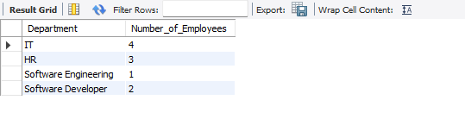

2.HAVING:
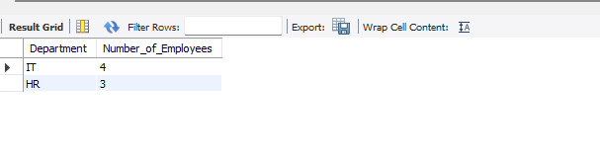
3.ORDER BY:
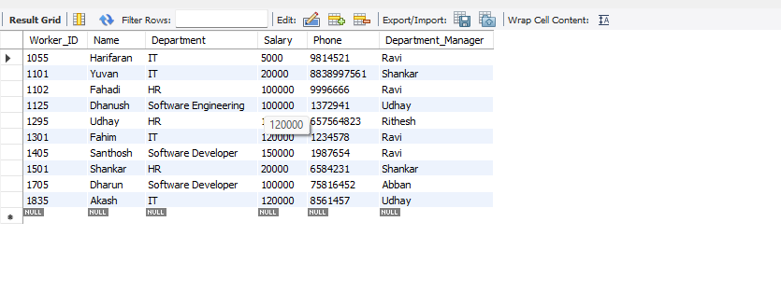

RESULT:
Thus, the GROUP BY, HAVING, and ORDER BY clauses were executed successfully on the employee table, and the desired output was obtained.

EXPIRIMENT 8:
AIM
To perform Subquery and Correlated Subquery operations on the employee table.
PROCEDURE :
- Create the company database and select the database.
- Create the employee table with the required fields.
- Insert employee records into the employee table.
- Display all the records from the employee table.
- Use a subquery to find employees whose salary is greater than the average salary.
- Use a subquery to find the employee having the maximum salary.
- Use a subquery to find employees belonging to the same department as a particular employee.
- Use a correlated subquery to compare each employee's salary with the average salary of their department.
- Use a correlated subquery to find employees having the highest salary in their respective department.
- Execute all the queries in MySQL Workbench and verify the results.
Record the output obtained for each query.
PROGRAM:
Step 1: Select Database
USE company;
Step 2: Create Employee Table
CREATE TABLE employee
(
Worker_ID INT PRIMARY KEY,
Name VARCHAR(50),
Department VARCHAR(30),
Salary INT,
Phone BIGINT,
Department_Manager VARCHAR(30)
);
Step 3: Insert Records
INSERT INTO employee VALUES
(1101,'Yuvan','IT',20000,8838997561,'Shankar'),
(1102,'Fahadi','HR',100000,9996666,'Ravi'),
(1301,'Fahim','IT',120000,1234578,'Ravi'),
(1405,'Santhosh','Software Developer',150000,1987654,'Ravi'),
(1501,'Shankar','HR',20000,6584231,'Shankar'),
(1705,'Dharun','Software Developer',100000,75816452,'Abban'),
(1835,'Akash','IT',120000,8561457,'Udhay'),
(1295,'Udhay','HR',120000,657564823,'Rithesh'),
(1125,'Dhanush','Software Engineering',100000,1372941,'Udhay'),
(1055,'Harifaran','IT',5000,9814521,'Ravi');
SUBQUERY
Question 1: Display employees whose salary is greater than the average salary.
SELECT Name, Salary
FROM employee
WHERE Salary > (
SELECT AVG(Salary)
FROM employee
);
Question 2: Display employees whose salary is equal to the maximum salary.
SELECT Name, Salary
FROM employee
WHERE Salary = (
SELECT MAX(Salary)
FROM employee
);
Question 3: Display employees who work in the same department as Yuvan.
SELECT Name, Department
FROM employee
WHERE Department = (
SELECT Department
FROM employee
WHERE Name = 'Yuvan'
);
CORRELATED SUBQUERY
Question 4: Display employees whose salary is greater than the average salary of their own department.
SELECT e1.Name, e1.Department, e1.Salary
FROM employee e1
WHERE e1.Salary > (
SELECT AVG(e2.Salary)
FROM employee e2
WHERE e2.Department = e1.Department
);
Question 5: Display employees who have the highest salary in their department.
SELECT e1.Name, e1.Department, e1.Salary
FROM employee e1
WHERE e1.Salary = (
SELECT MAX(e2.Salary)
FROM employee e2
WHERE e2.Department = e1.Department
);

OUTPUT:
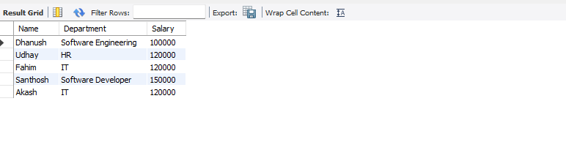
RESULT :
Thus, the Subquery and Correlated Subquery operations were executed successfully on the employee table in the company database, and the required records were retrieved successfully

EXPIREMENT:9
Query with Joins – EquiJoin, InnerJoin, OuterJoin
AIM:
To perform JOIN operations such as Equi Join, Inner Join and Outer Join on the employee-related tables.
PROCEDURE:
- Select the company database.
- Create the employee table.
- Create a second table containing department information.
- Insert records into both tables.
- Use Equi Join / Inner Join to display matching employee and department records.
- Use Left Join to display all employee records along with matching department details.
- Use Right Join to display all department records along with matching employee details.
- Execute the queries in MySQL Workbench.
Verify the Result Grid.
PROGRAM:
EQUI JOIN
1. Display employee name, department and manager name using Equi Join.
SELECT e.Name,
e.Department,
d.Manager
FROM employee e
JOIN department d
ON e.Department = d.Department;

INNER JOIN
2. Display the employee name and salary along with their department manager.
SELECT e.Name,
e.Salary,
d.Manager
FROM employee e
INNER JOIN department d
ON e.Department = d.Department;

LEFT OUTER JOIN
3. Display all employees and their corresponding department manager.
SELECT e.Name,
e.Department,
d.Manager
FROM employee e
LEFT JOIN department d
ON e.Department = d.Department;
This displays all employees, even if a matching department is not available.

RIGHT OUTER JOIN
4. Display all departments and the employees working in each department.
SELECT d.Department,
d.Manager,
e.Name
FROM employee e
RIGHT JOIN department d
ON e.Department = d.Department;
This displays all departments, including departments that currently have no employees.

5. Display employee name, department and salary for employees working in departments managed by Ravi.
SELECT e.Name,
e.Department,
e.Salary,
d.Manager
FROM employee e
INNER JOIN department d
ON e.Department = d.Department
WHERE d.Manager = 'Ravi';
OUTPUT:

1.EQUI JOIN:
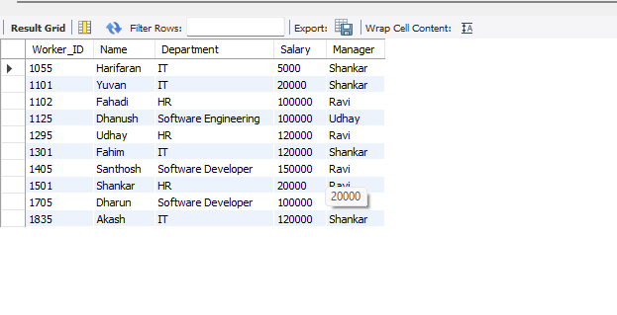

2.INNER JOIN:
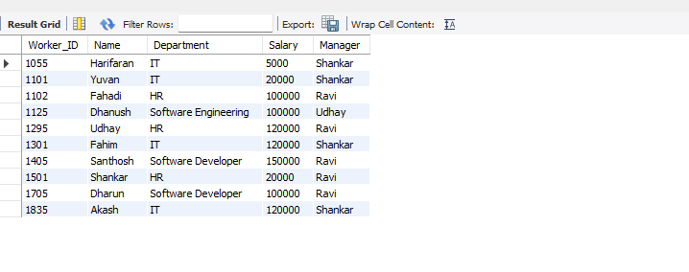

3.OUTER JOIN:
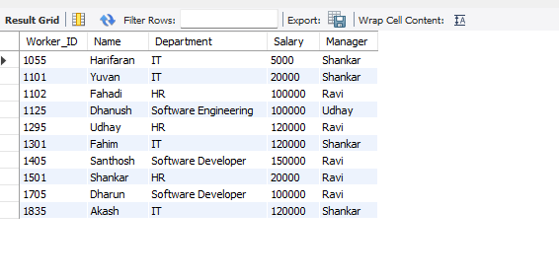

RESULT:
Thus, the Equi Join, Inner Join and Outer Join operations were executed successfully on the employee and department tables, and the required records were retrieved successfully.
EXPIREMENT:10
Database with VIEW and INDEX
AIM:
To create and use VIEW and INDEX on the given relation.
PROCEDURE:

- Select the company database.
- Create the employee table.
- Insert employee records into the table.
- Create a view named v1 containing selected employee details.
- Display the records from the view.
- Insert a record through the view.
- Delete a record through the view.
- Create an index on the Salary column.
- Use the indexed column to retrieve employees based on salary.
- Display the required output.
- Drop the index after completing the operation.

PROGRAM:
Question 1 – Create VIEW
USE company;

CREATE OR REPLACE VIEW v1 AS
SELECT Worker_ID, Name, Salary
FROM employee;

Question 2 – Display VIEW
SELECT * FROM v1;
Output
Worker_ID | Name | Salary
1101 | Yuvan | 20000
1102 | Fahadi | 100000
1301 | Fahim | 120000
1405 | Santhosh | 150000
1501 | Shankar | 20000
1705 | Dharun | 100000
1835 | Akash | 120000
1295 | Udhay | 120000
1125 | Dhanush | 100000
1055 | Harifaran | 5000

Question 3 – Insert Record Through VIEW
INSERT INTO v1
VALUES (2001, 'Arun', 80000);

SELECT * FROM v1;
The new employee will appear in the view.

Question 4 – Delete Record Through VIEW
DELETE FROM v1
WHERE Worker_ID = 2001;

SELECT * FROM v1;
The employee with Worker_ID = 2001 will be removed.

INDEX
Question 5 – Create Index on Salary
CREATE INDEX index_salary
ON employee(Salary);
Now display employees whose salary is greater than 100000:
SELECT *
FROM employee
WHERE Salary > 100000;
Output
Worker_ID | Name | Department | Salary
1301 | Fahim | IT | 120000
1405 | Santhosh | Software Developer | 150000
1835 | Akash | IT | 120000
1295 | Udhay | HR | 120000

Question 6 – Create Index on Worker_ID
CREATE INDEX index_worker
ON employee(Worker_ID);
Display the employee with Worker_ID 1101:
SELECT *
FROM employee
WHERE Worker_ID = 1101;
Output
Worker_ID | Name | Department | Salary
1101 | Yuvan | IT | 20000

Question 7 – Drop Indexes
DROP INDEX index_salary ON employee;

DROP INDEX index_worker ON employee;
OUTPUT:
1. VIEW: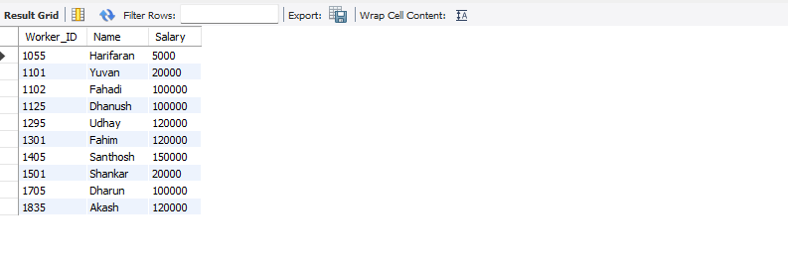

2.INDEX:
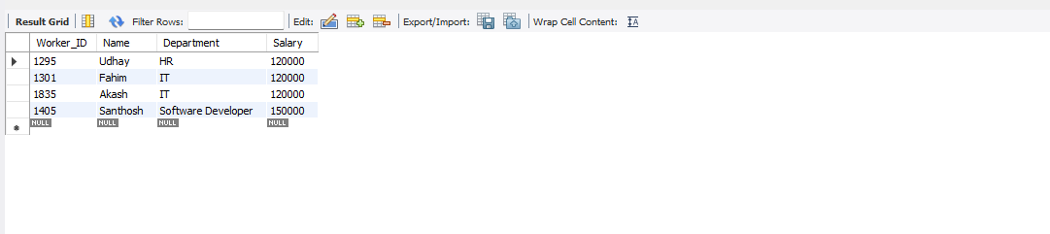
RESULT:
Thus, the VIEW and INDEX operations were executed successfully on the employee table in the company database, and the required records were retrieved and displayed successfully.

